NETWORKING & SYSTEM ADMINISTRATION LAB

**Name: Nikhil Jais**

**Roll No:25**

**Batch B 31-3-2022**

Experiment No.: 4

Aim

Familiarization of basic Linux commands.

Procedure

1. **cat -n /cat -b [filename] :** To display line numbers

Syntax : $ cat -n filename Output :



1. **touch filename :** To create an empty file.

Syntax : $ cat filename

Output :



1. **echo :** To add content to an empty file created using touch command.

Syntax : $ echo [content] >> filename Output :



1. **head :** By default, it prints the first 10 lines of the specified files.

Syntax : $ head [filename] Output :



1. **head -4 [filename] :** To print first n lines of specified files.

Syntax : $ head -n [filename]

Output :



1. **tail :** By default, print last 10 lines of specified file.

Syntax : $ tail [filename]

Output :



1. **tail -3 [filename] :** To print last n lines of specified files.

Synatx : $ tail -n [filename]

Output :



1. **cut -d- -f2 [filename] :** It can be used to cut parts of a line by field.

Syntax : $ cut -d "delimiter" -f (field number) file.txt

Output :



1. **rmdir :** Used to delete a directory if it is empty.

Syntax : $ rmdir [directory name] Output :



1. **cut -b 2 [filename] :** It can be used to cut parts of a line by byte position(n).

Syntax : cut -b num [filename] Output :

1. **cut --complement -c 1 [filename] :** This option instructs cut to display all the fields, bytes or characters except the selected.

Syntax : $ cut –complement -c num [filename] Output :



1. **paste marvel1 marvel2 :** To paste the content in one file to another file.

Syntax : $ paste file1 file2 Output :



1. **paste marvel1 marvel2 > marvel3 :** To paste the contents of two given files to a third file.

Syntax : $ paste file1 file2 > file3 Output :



1. **paste -d ‘ - ’ marvel1 marvel :** The -d, -delimiters option allows you to specify a list of characters to be used as delimiters instead of the default separator.

TAB

Syntax : $ paste -d ‘ - ’ file1 file2 Output :



1. **paste -d ‘%|’ marvel1 marvel2 marvel1 :** Two delimiters are used. If more than one character is specified as delimiter then paste uses it in a circular fashion for each file line separation.

Syntax : $ paste -d ‘%|’ file1 file2 file1

Output :



1. **paste -s marvel1 marvel2:** This command will merge all lines from the given file in separated lines.

Syntax : $ paste -s file1 file2

Output :



1. **more name :** The more command displays the first section of the file. By pressing the “ENTER” key, we can scroll line by line, all the way to the bottom of the file.

Syntax : $ more filename

Output :



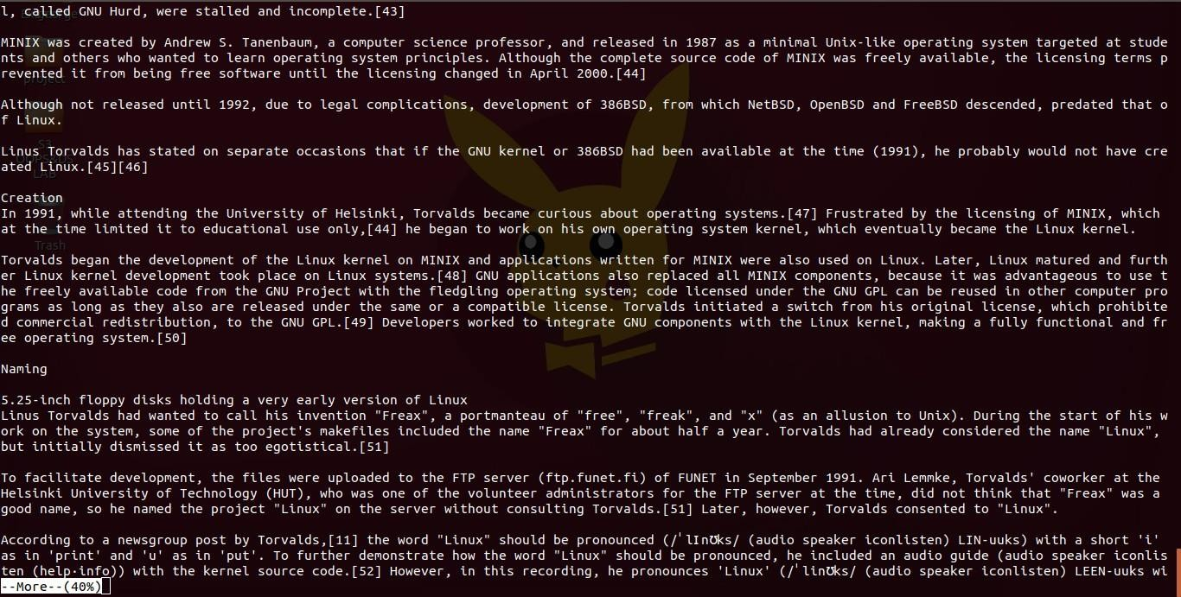

1. **more -3 name :** Used to type the number of lines(num) to display per screen.

Syntax : $ more -num filename

Output :



**19.more +3 name :** This option displays the text after the specified number of lines of the document.

Syntax : $ more +num filename

Output :

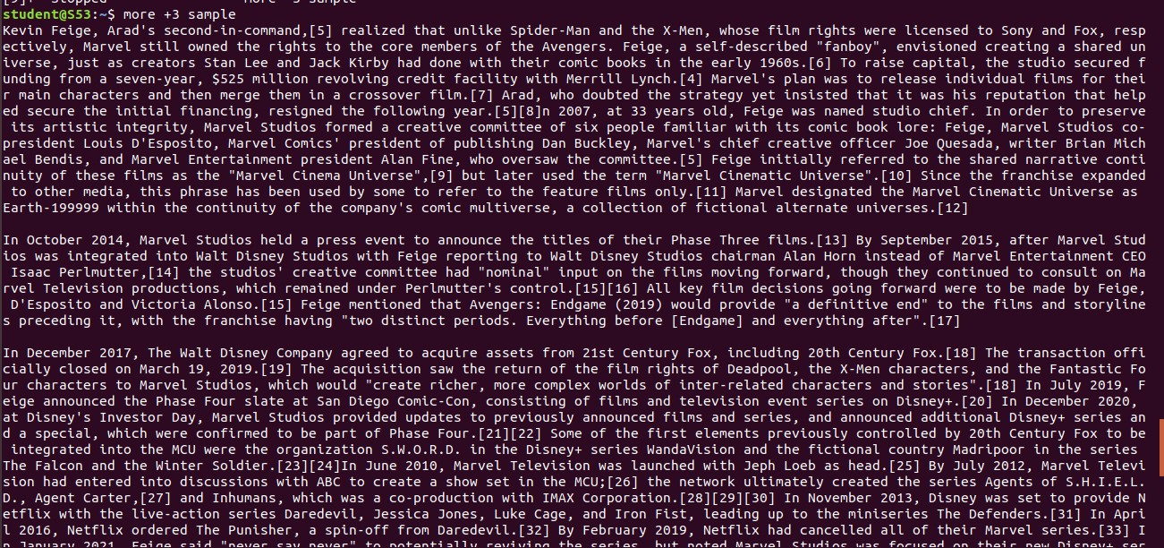

**20. more -s name :** This option squeezes multiple blank lines into one single blank line.

Syntax : $ more -s filename Output :

